“Notice of Virtual Preliminary Public Meeting”

RE: Gray Village Transformation Project – Virtual Preliminary Public Meeting
WIN: 024613.10
Dear Property Owner:
The Maine Department of Transportation, in partnership with the Town of Gray, will be conducting a virtual preliminary public meeting from Wednesday, October 14th through Wednesday, October 28th.
The project information being shared includes multiple sections along U.S. and State Routes, including:
- U.S. Route 202 (West Gray Road & Main Street)
- State Route 115 (Yarmouth Road)
- State Route 26/100 (Portland Road)
- Local roads including Shaker Road, Center Road, Brown Street, and Colley Hill Road
Project limits are as follows:
- U.S. Route 202: Begins 0.14 miles east of McConkey Road and extends northeast 1.10 miles (just south of Wayne Avenue).
- State Route 26/100: Begins at U.S. Route 202 and extends southwest 0.24 miles (terminating adjacent to Gray Plaza).
- State Route 115 (Yarmouth Road): Begins at U.S. Route 202 and extends east 0.67 miles (terminating adjacent to Hillcrest Drive).
- Shaker Road: Begins at Gray Park Road (southerly end) and extends 0.22 miles to the intersection with U.S. Route 202.
Additionally, new town ways are anticipated as cut-throughs/bypasses to improve access around the village intersections, connecting U.S. Route 202 through Center Road to Route 26/100/4 (Portland Road).

Because your property is adjacent to or in close proximity to the proposed project improvements, you are specifically invited to review the Virtual Public Meeting and learn more about the proposed project.
Please scan the QR code below or enter the web link provided below to access the projects story map to review the proposed improvements, and provide comments or feedback.
QR Code to story map.


Link to storymap:
mainedot.info/4dskVYe
Should you have any questions, please contact me at 207-624-3381 or by email at Ernest.Martin@maine.gov.
Sincerely,
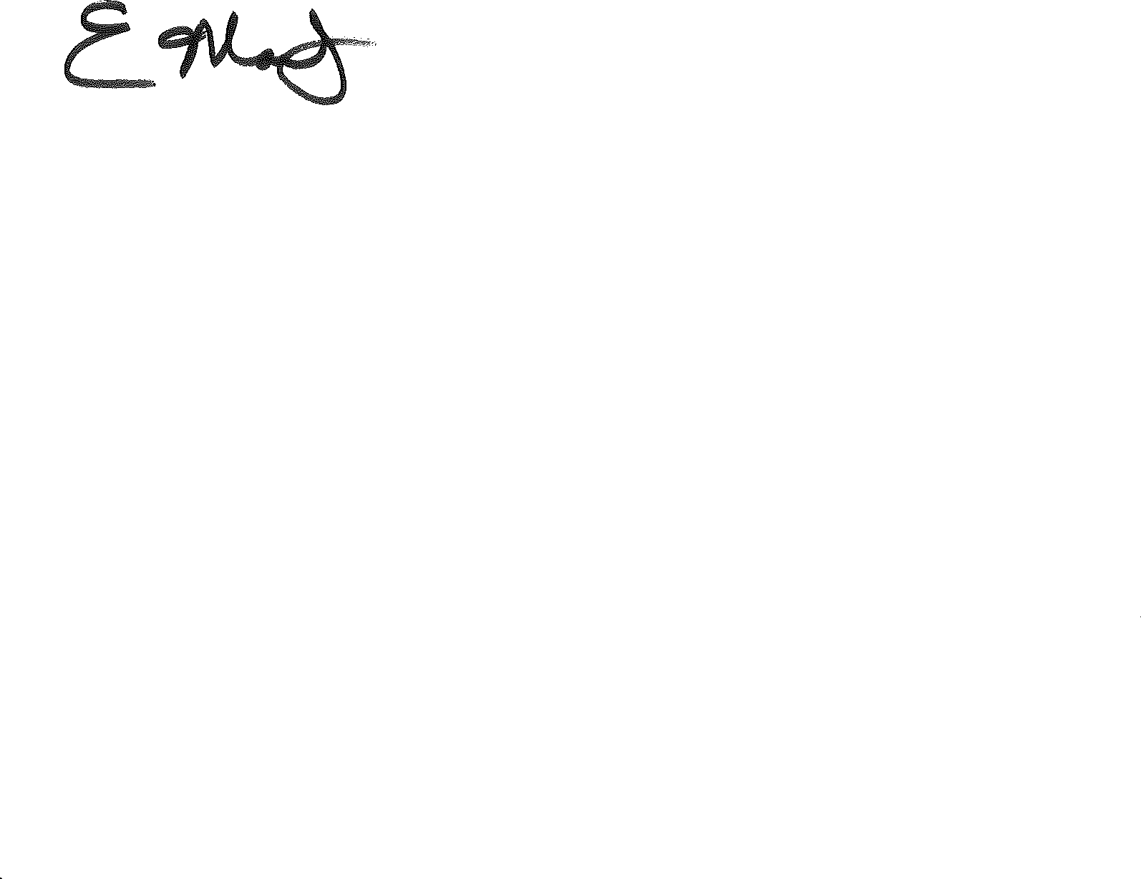
Ernie Martin
Senior Project Manager
Highway Program

